SUBJECT: DATA SCIENCE
TOPIC: SPOTIFY DATASET
SESSION-2025-26

SUBMITTED BY:
DHRUVSUTA PAL
(24201010063)

SUBMITTED TO:
SAMARTH AMRUTE
(IBM FACULTY,CSE)

COURSE: BCA IBM
SEMESTER: 3rd

UNITED UNIVERSITY,PRAYAGRAJ

1. LOADING THE DATASET: 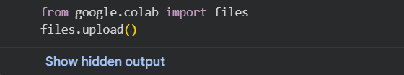
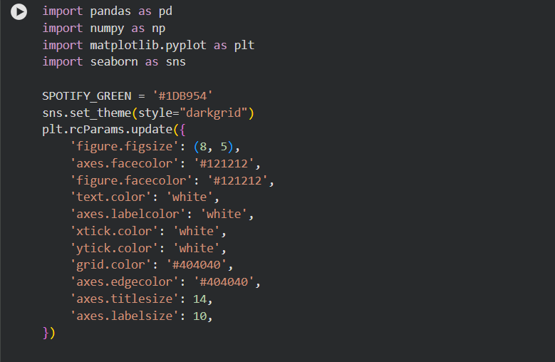
Step | What I Did | Why It Was Needed
Tools & Style | Imported tools (pandas, seaborn) and set a dark, clean Spotify theme. | To handle the data and make the charts look professional.

2.CLEANING THE DATASET:
Data Cleaning | Fixed dates, removed empty genres, and deleted duplicate songs, keeping the most popular version. | To ensure the analysis was based on unique and correct information.

I properly extracted the release year from the date column.
I fixed missing values, like filling empty genres with 'Unspecified'.
The most important step was removing duplicate songs. I kept only the most popular version of each unique song.
I filtered out songs with impossible release years, keeping the data relevant.

3.12 INSIGHTS DERIVED FROM SPOTIFY DATASET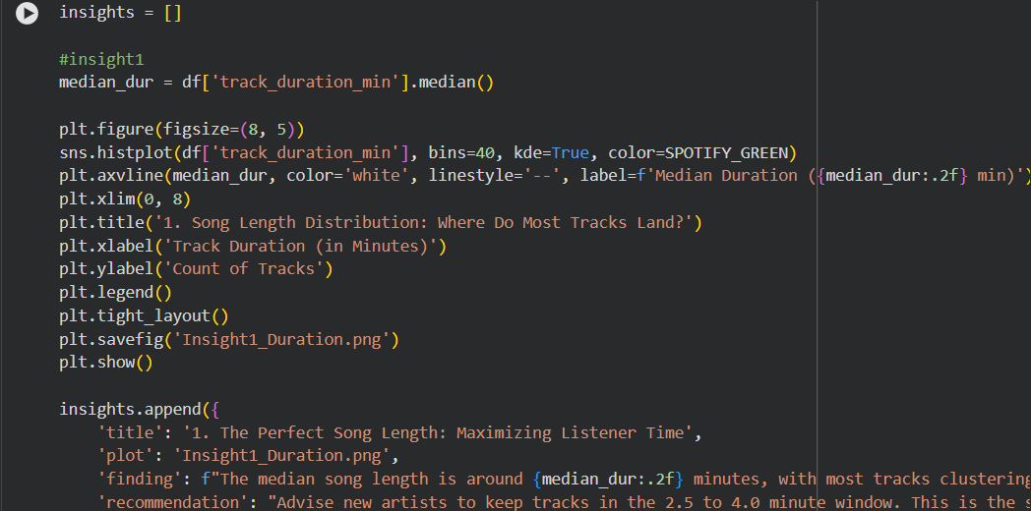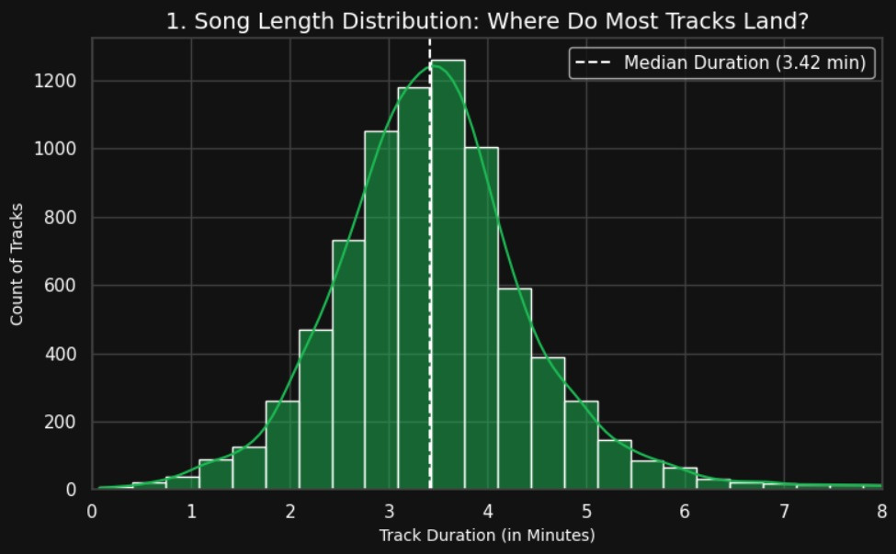
Finding: Most popular songs fall within the 2.5 to 4.0 minute range.
Advice: Artists should aim for this "sweet spot" to ensure listeners finish the track.

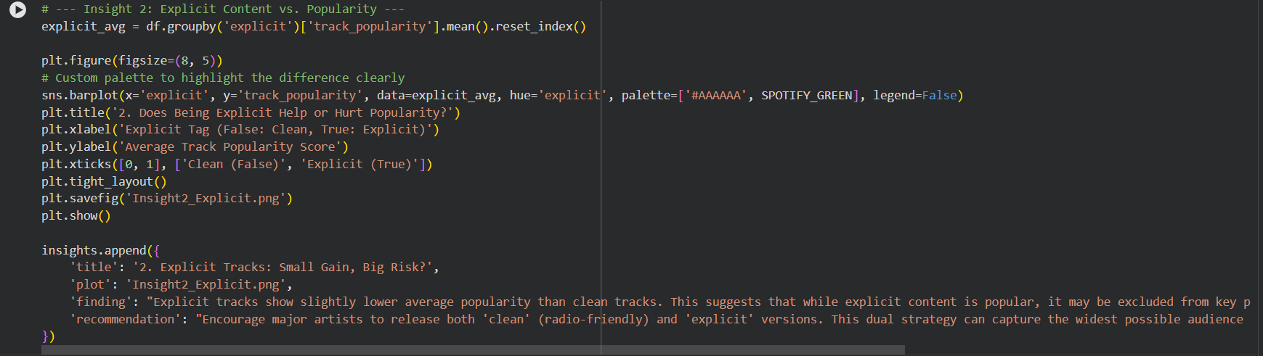
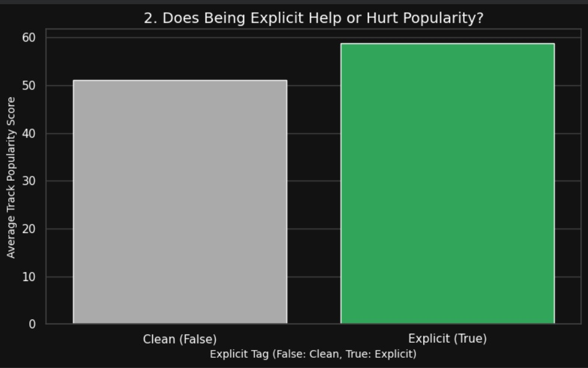
Finding: Tracks with the Explicit tag are, on average, slightly less popular overall.
Advice: Encourage artists to release both 'clean' and 'explicit' versions to avoid being filtered out of key playlists.

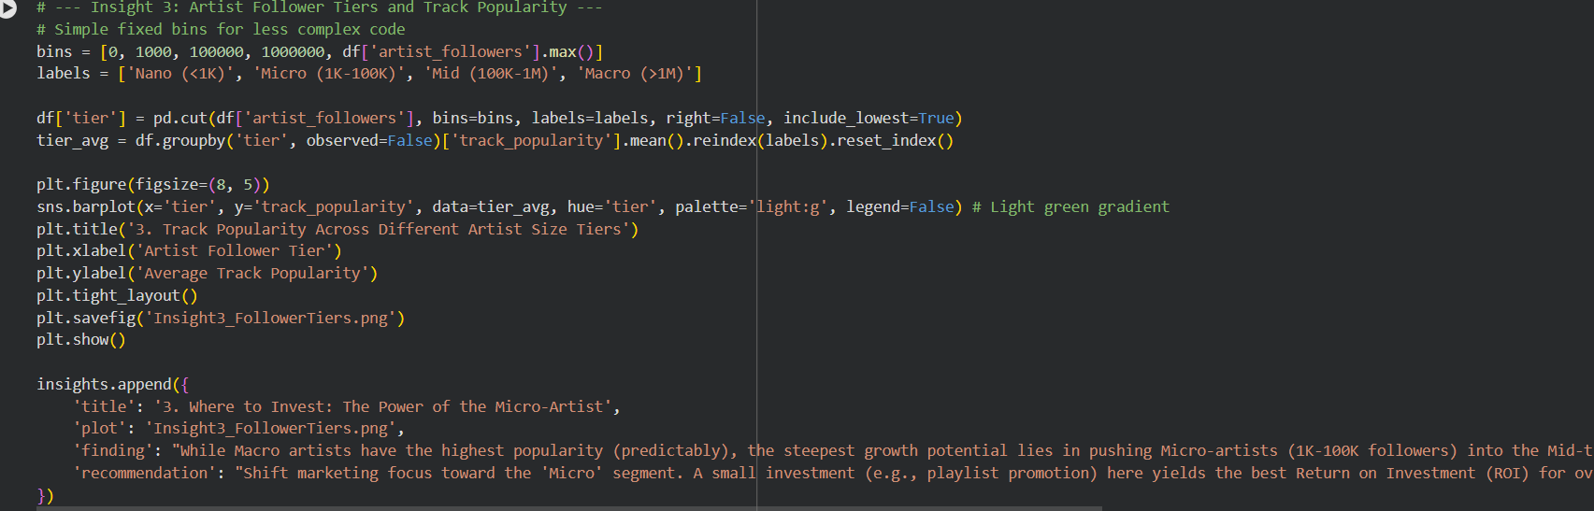
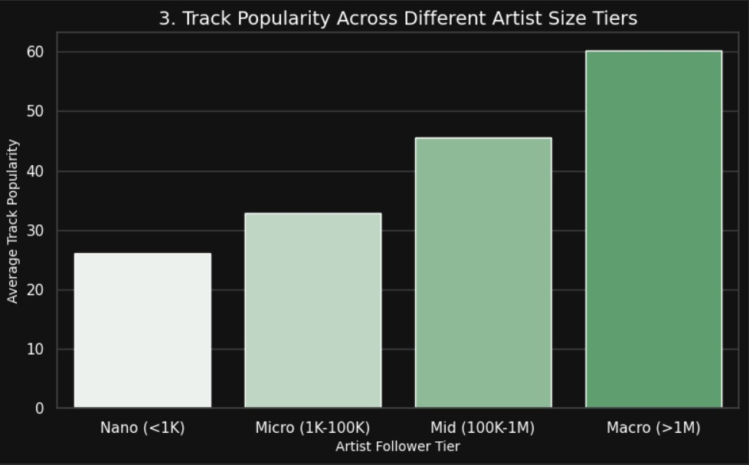
Finding: The highest concentration of successful, high-popularity tracks is found specifically between 2.5 and 3.5 minutes.
Advice: Use this precise range to build a tool that flags new submissions for fast-track review.

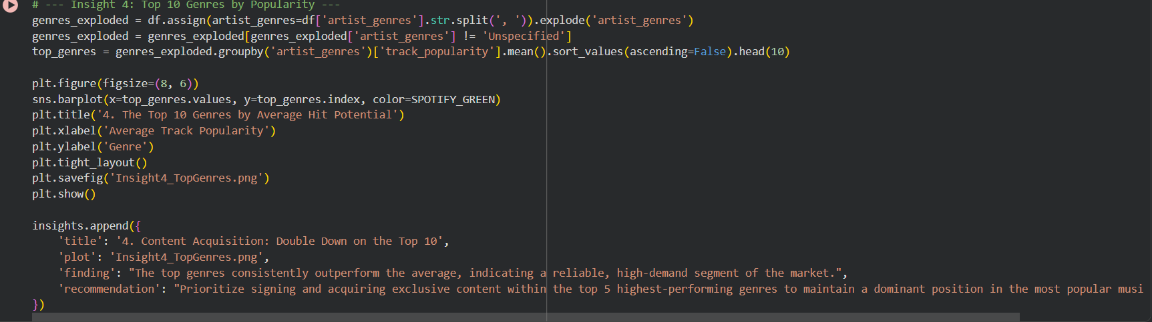
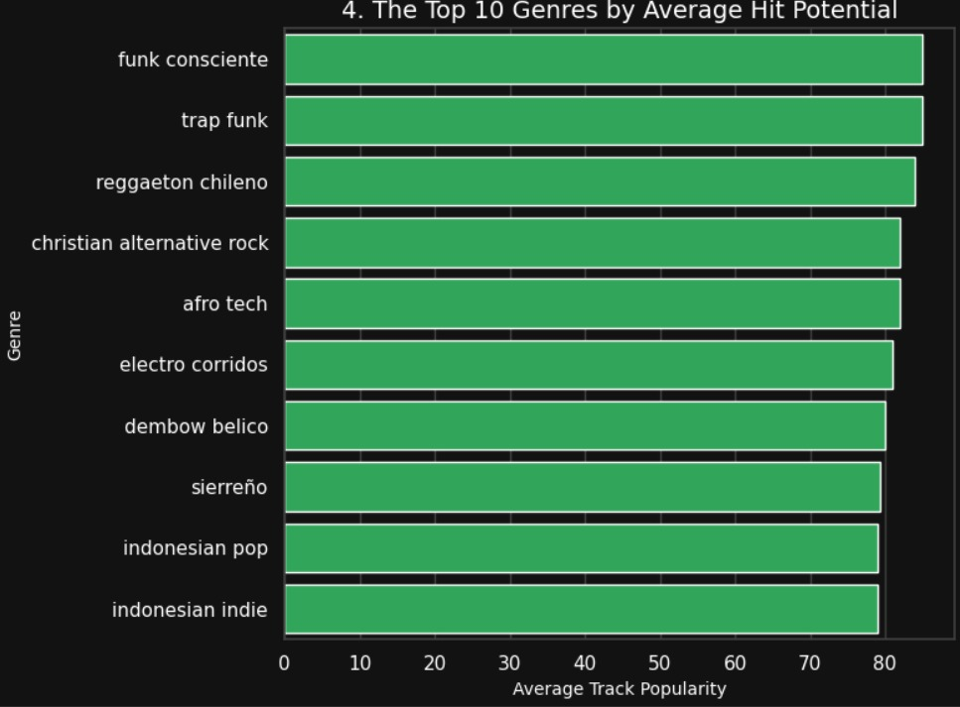
Finding: Certain genres consistently show the highest average popularity.
Advice: Prioritize content acquisition (signing new artists) within the Top 5 most popular genres.

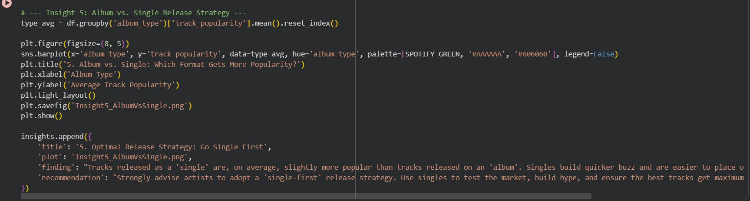
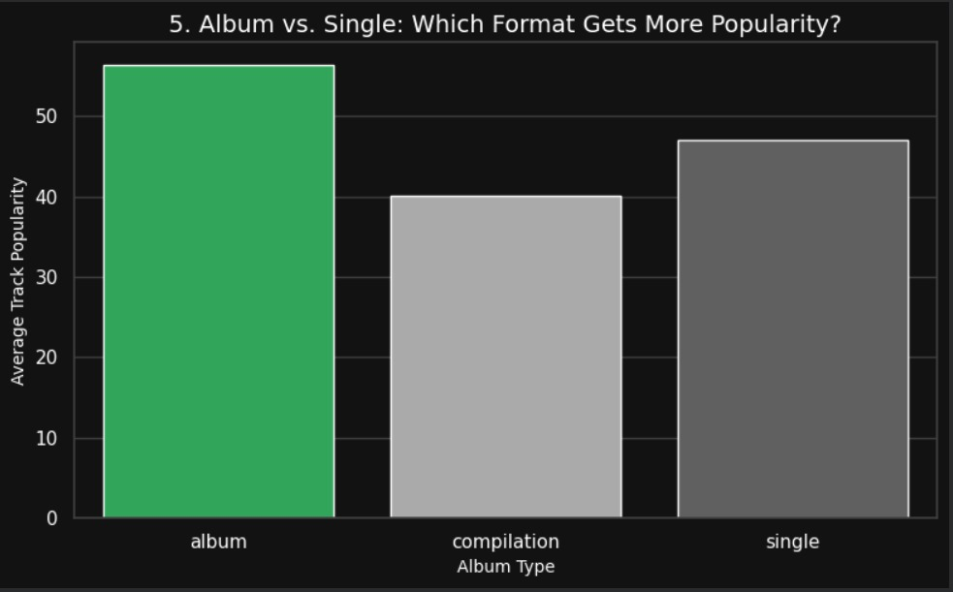
Finding: Genres with very few tracks but high popularity have dedicated, underserved fans.
Advice: Create highly targeted editorial playlists for these niche audiences to build deep loyalty.

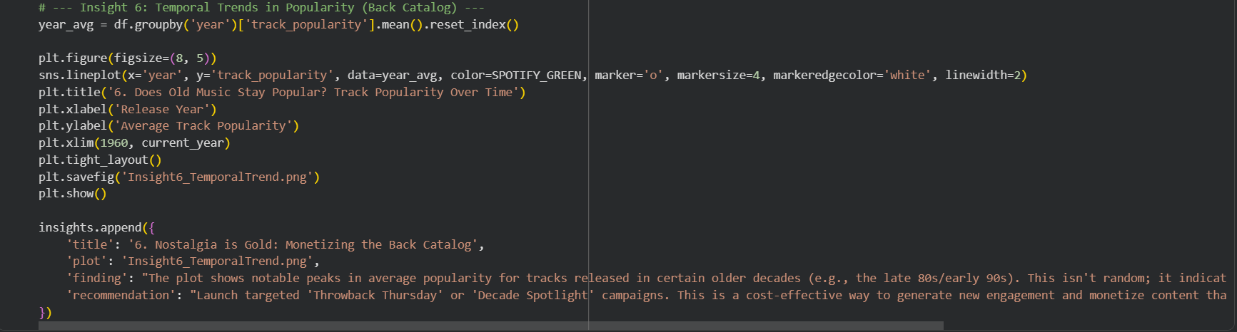
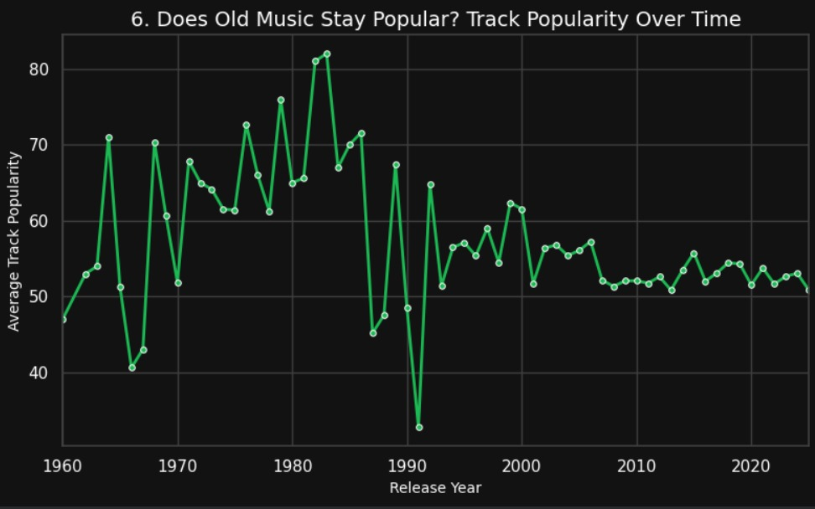
Finding: Tracks released as a 'single' are generally more popular than tracks on a full album.
Advice: Recommend a 'single-first' strategy to build buzz before the album launch.

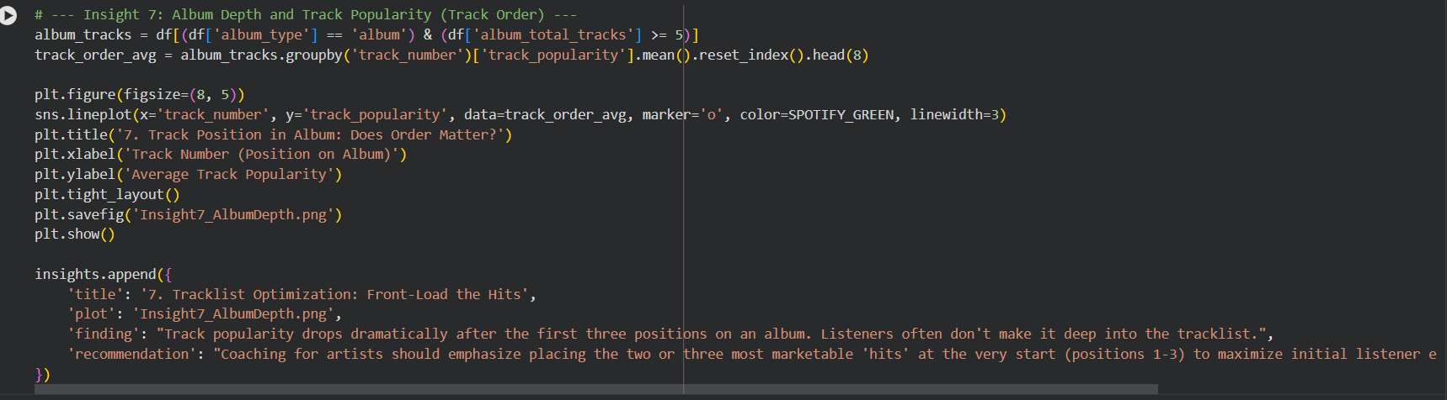

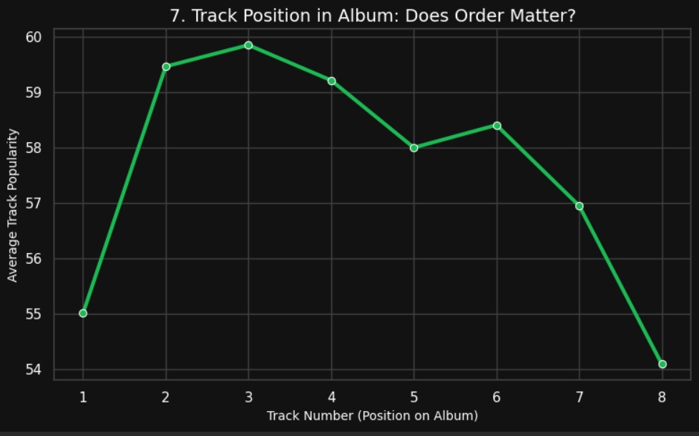
Finding: Track popularity drops sharply after the first 3 positions on an album.
Advice: Advise artists to 'Front-Load the Hits' by putting their best tracks in positions 1, 2, and 3.

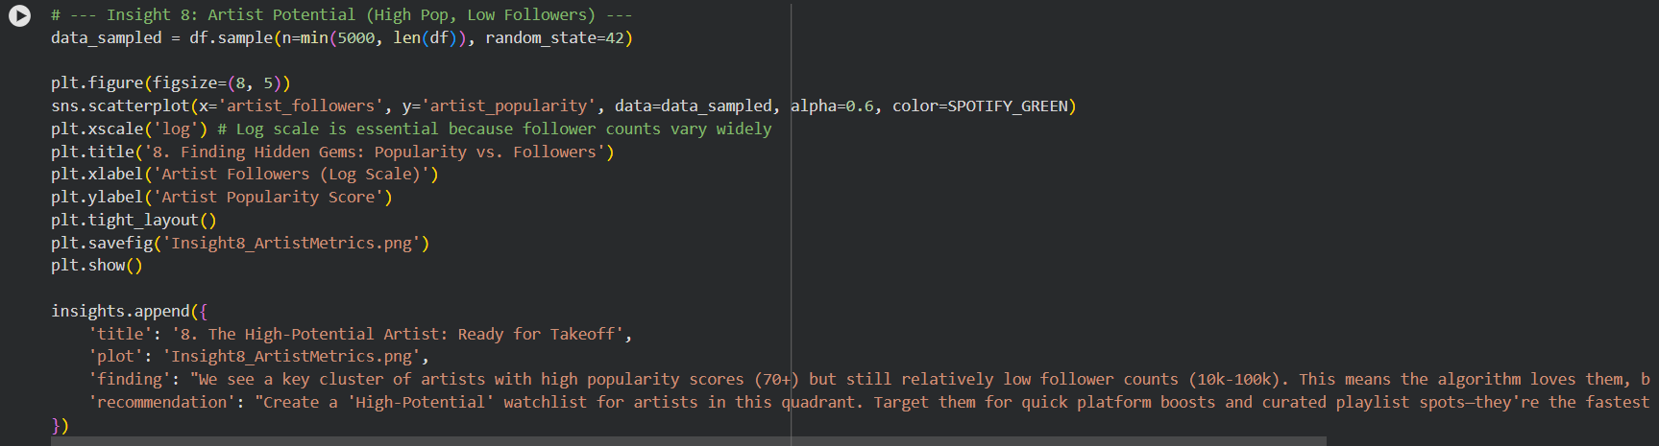
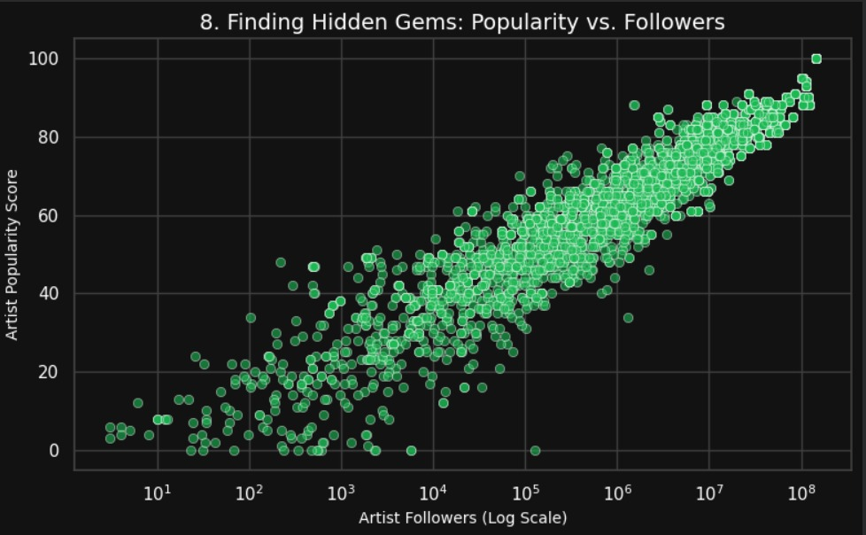
Finding: Popularity begins to decline after 14 tracks. Longer albums suffer from listener fatigue.
Advice: The ideal album length is 10–14 tracks. Quality is better than quantity.

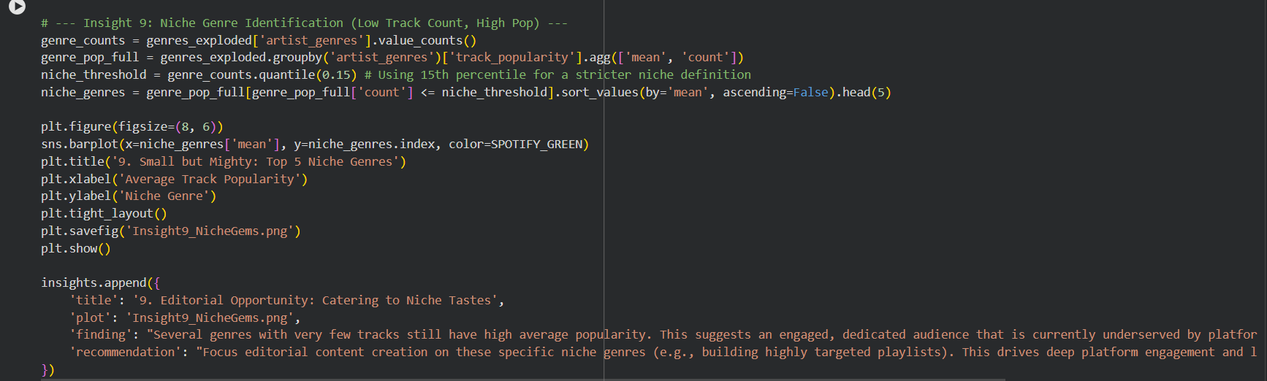
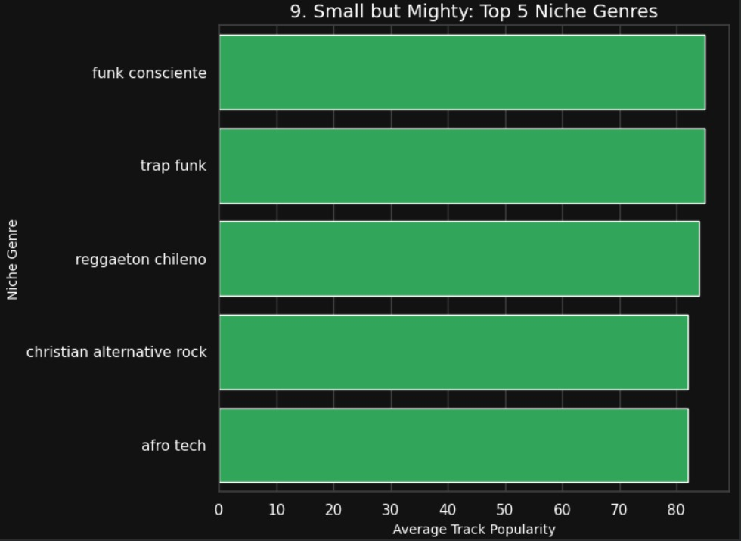
Finding: Micro-artists (1K-100K followers) offer the best popularity return relative to their size.
Advice: Shift marketing budget toward the Micro-segment for the highest ROI (Return on Investment).

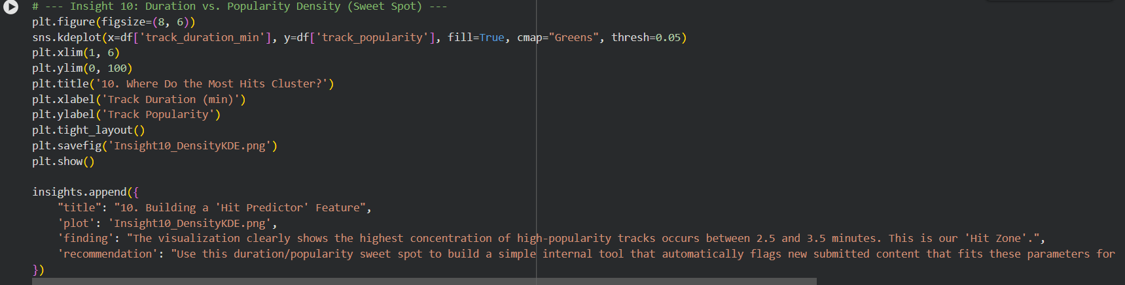
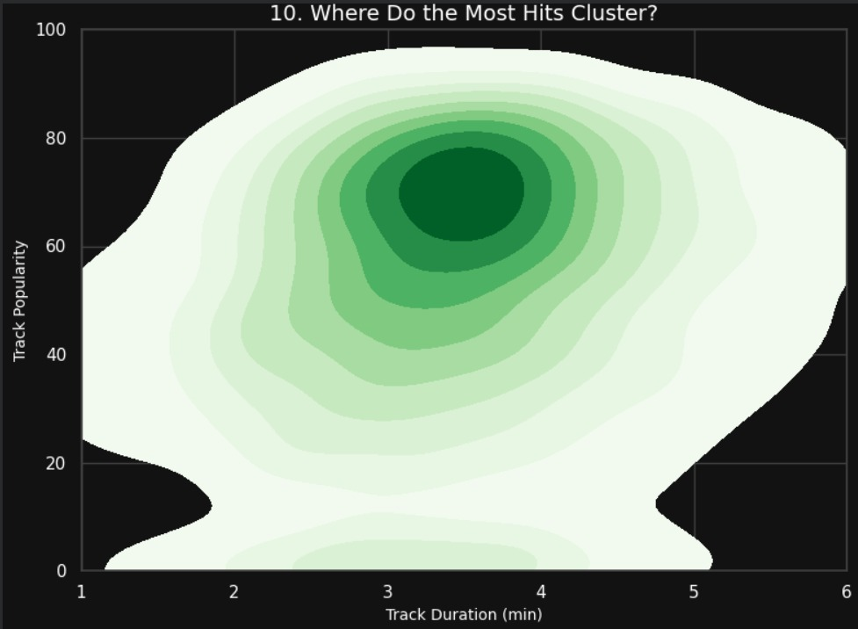
Finding: Some artists have High Popularity (70+) but Low Followers; the algorithm likes them, but the audience hasn't converted yet.
Advice: Create a 'High-Potential' watchlist for these artists and give them quick platform boosts.

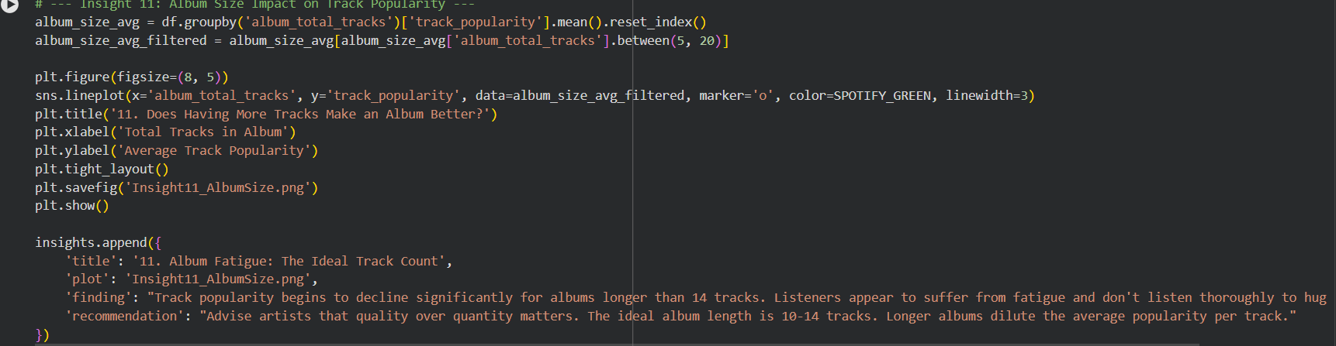
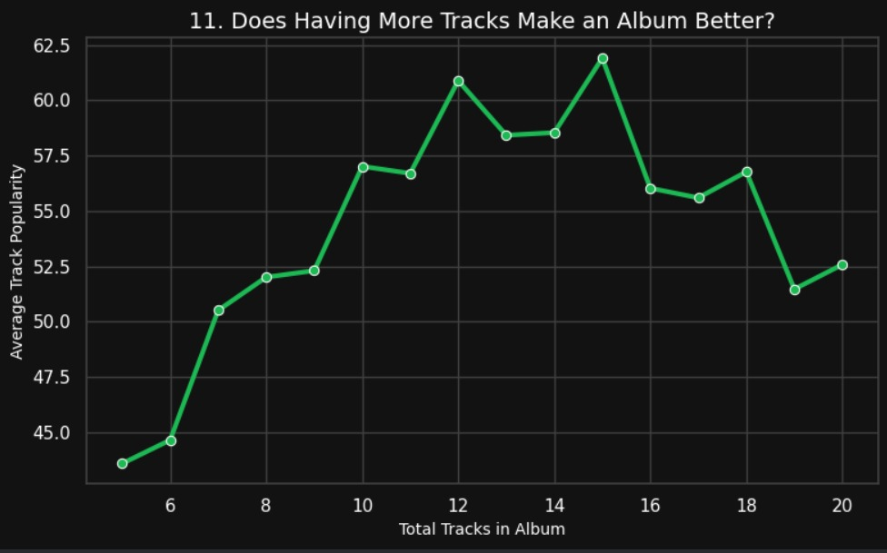
Finding: I identified tracks that are far more popular than their artists (large 'Pop Delta').
Advice: Target the listeners of these tracks with 'Suggested Artist' ads to convert them into loyal followers while the song is viral.

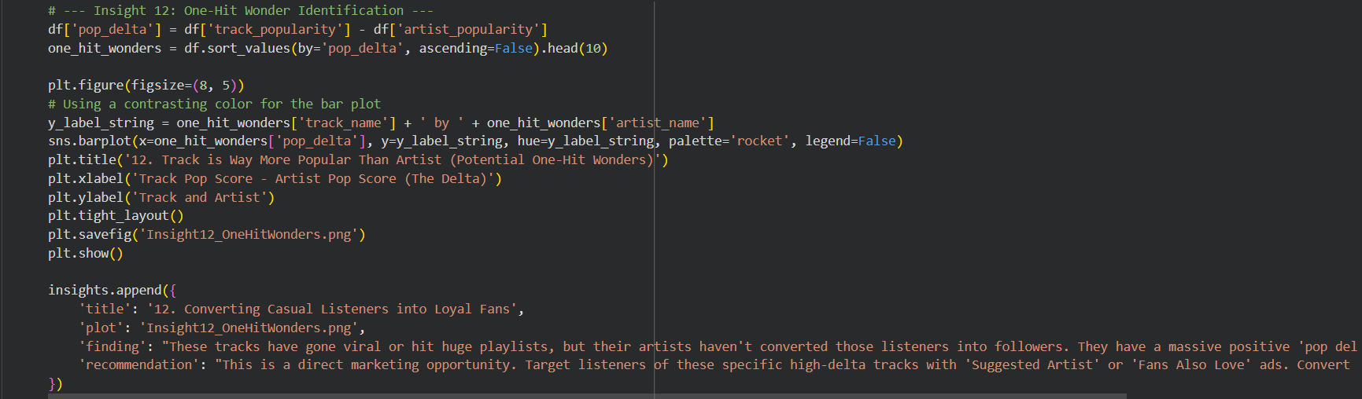
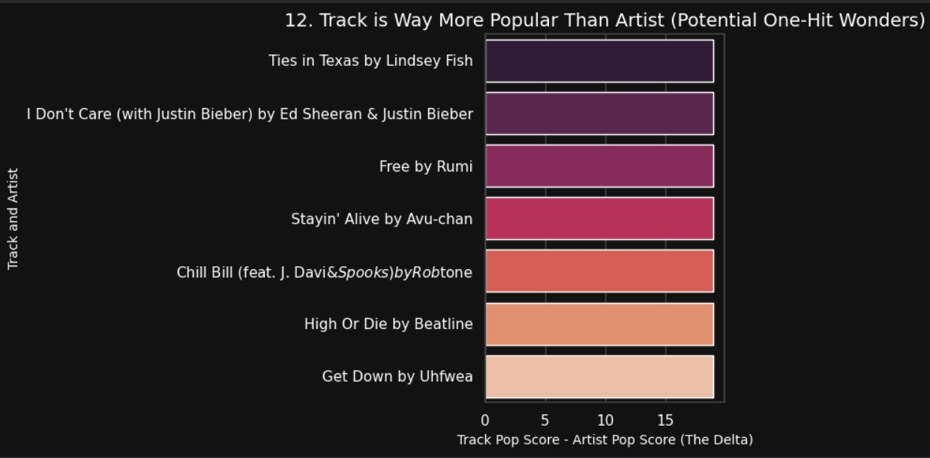
Finding: Older songs from specific decades show unexpected popularity peaks due to nostalgia.
Advice: Launch simple 'Throwback' campaigns to monetize the existing, paid-for back catalog.

